Asset Management

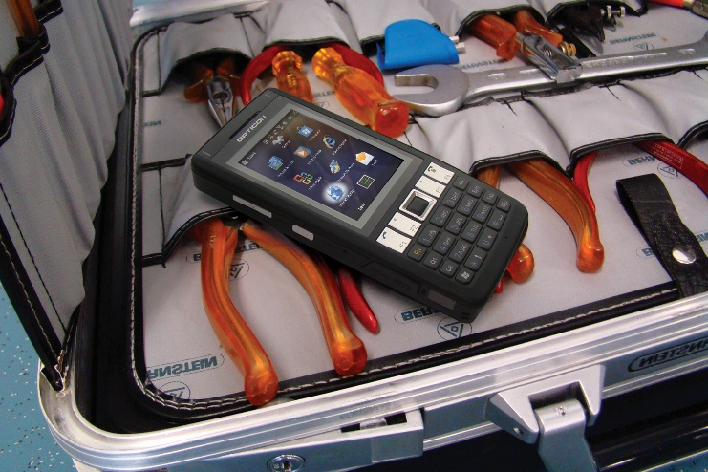

**Tools Used**

Working at the help desk will require a variety of tools for many different situations. Common tools include screwdrivers, boxes of small screws for electronics, and pliers. Other tools include soldering iron, hard drives, hard drive testers, cable cutters, and various cables. All of these tools must be put away to their appropriate locations where found before. Organization of these tools are important so every technician is able to locate every tool needed for efficiency.

**Security**

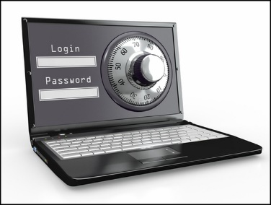

Not only is organization important, but so is how they are put away. Security involves keeping all items locked away for safety. There are dangerous tools used such as soldering irons or sharp tools like screwdrivers so locking up all tools are important. Personal tools and items used at the help desk should be protected with passwords and put away safely. All users logged onto the computers provided at the help desk should be password protected and need to be logged out of when done. WiFi encryption is important to not just help desk technicians, but for every person on campus. Wireless networks must be encrypted and require a valid username and password to access the network.